Your report can show a number of different totals. A "total" can be any of the aggregate functions, including Sum, Avg, Max, Min, and Count.

Totals over what?
- Whole report
- Group
- Running sum in each record
It will be important to make it clear what is being totaled!
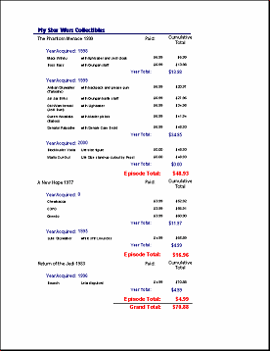
Whole report = Grand Total, Groups = Year Total & Episode Total, Running Sum = Cumulative Total with each Detail
Your report can easily show totals like sums, averages, and counts based on the fields in the report's source. You can total each group in a Group Header or Footer. You can total the whole report in the Report Header or Footer.

How to put a total in a report:
- Create an unbound text box control in a header or footer.
- Set the control source for the new control to an expression that calculates the total that you want.
General Syntax: =Function([FieldName])
Examples: =Sum([Price]) or =Avg([Price]) or =Max([Price]) where the field named Price is in the report's source.
The field that you are totaling is usually shown in the Detail section but does not have to be.
What will be totaled: Group or Report?
It depends on which section you put the new control. If it is in a group header or footer, then the total is over that group only. If it is in the report header or footer, then the total is for the whole report.

